**LAB # 06**



**Spring 2022**

**Operating Systems**

**Submitted by: Maaz Habib, Alishba Orakzai, Nida Asmat Burki**

**Registration no. 20PWCSE1952 ,20pwcse1953, 20pwcse1955**

**Class Section: C**

**“On my honor, as student of University of Engineering and Technology, I have neither given nor received unauthorized assistance on this academic work.”**

**Submitted to: SIR IBAD**

**May 31 , 2022**

**Department of Computer Systems Engineering**

**University of Engineering and Technology, Peshawar**

**EXAMPLE 01:**

**CODE:**

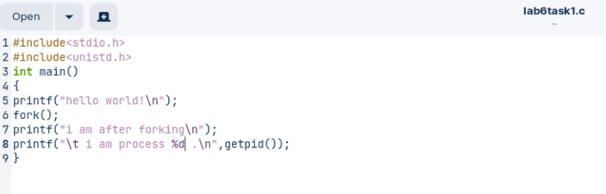

**OUTPUT:**

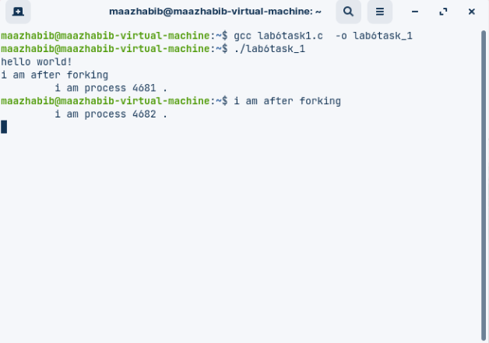

**EXAMPLE 02:**

**CODE:**

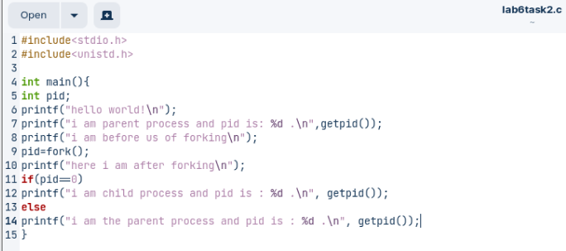

**OUTPUT:**

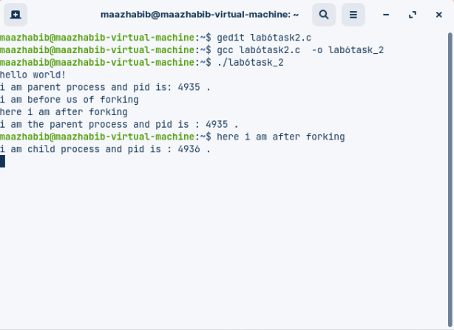

**EXAMPLE 03:**

**CODE:**

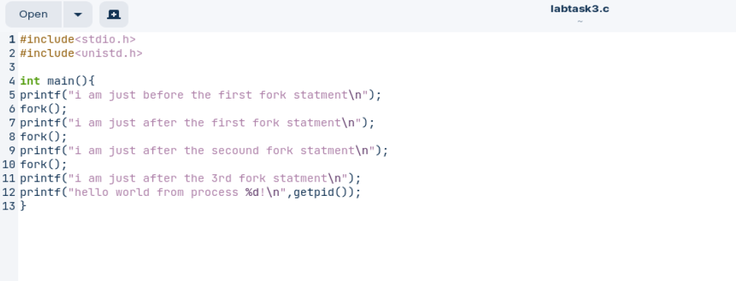

**OUTPUT:**

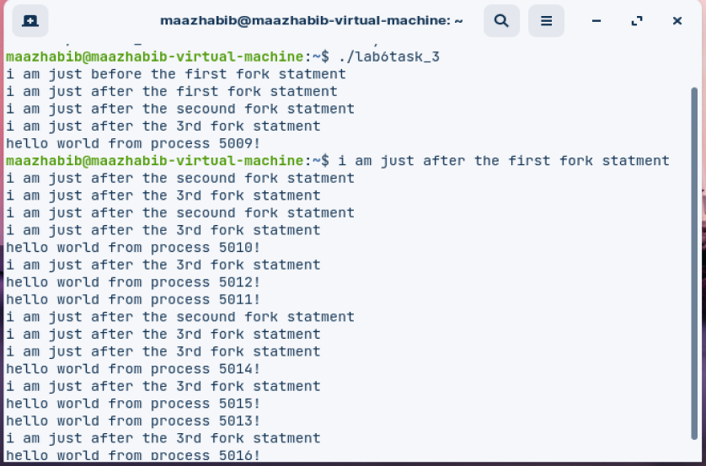

**EXAMPLE 04:**

**CODE:**

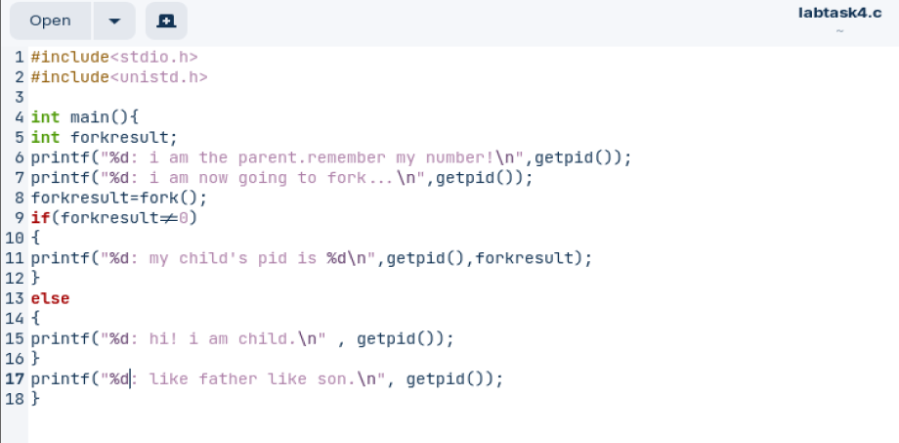

**OUTPUT:**

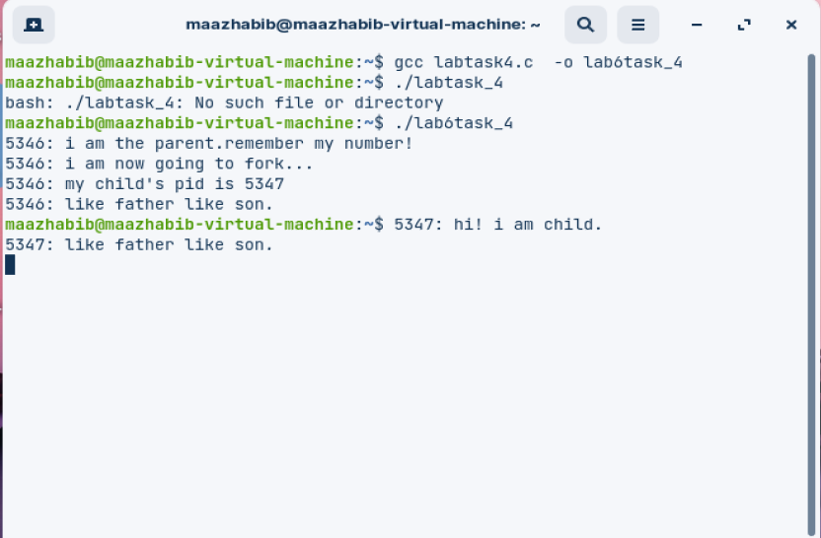

**Assignment task no 01**

**Code**

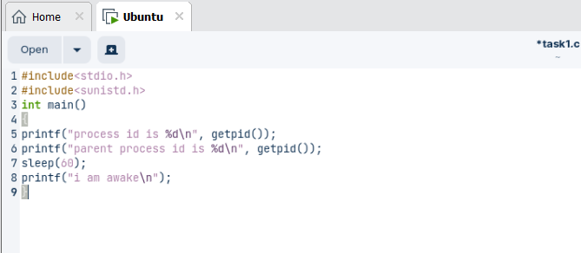

**output**

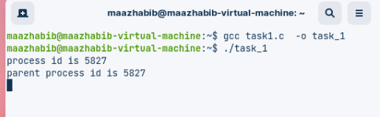

**Task2**

**Code**

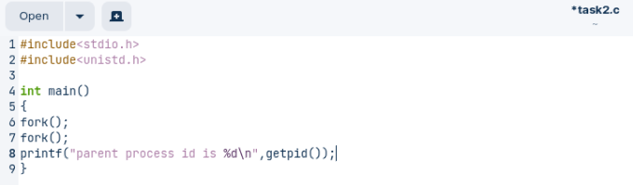

**Output**

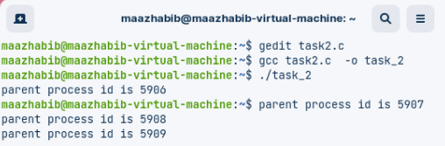

**Task3**

**Code**

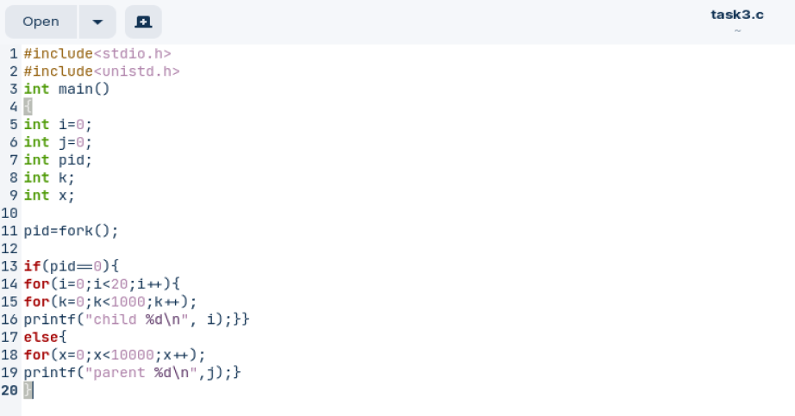

**Output**

